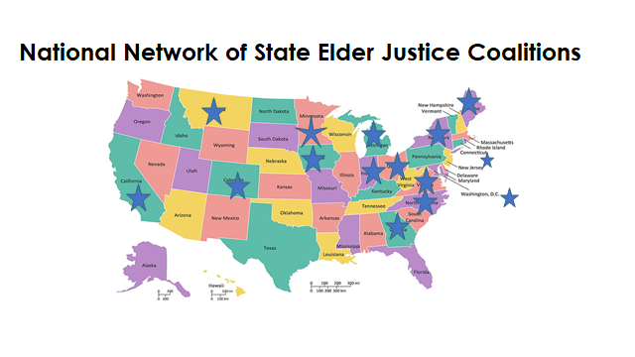

**16 Coalition Members Representing 15 States (April 2023)**

•        California Elder Justice Coalition

•        Colorado Coalition for Elder Rights and Abuse Prevention

•        Connecticut – Coalition for Elder Justice in Connecticut

•        District of Columbia – DC TROV The District’s Collaborative Training and Response for Older Victims

•        Georgia Coalition for Adult Abuse Prevention

•        Iowa Abuse in Later Life, Coordinated Community Response Team

•        Indiana Council Against Senior Exploitation (IN-CASE)

•        Maine Council for Elder Abuse Prevention

•        Michigan Elder Justice Coordinating Council

•        Minnesota Elder Justice Center

•        Montana Elder Justice Council

•        New York State Coalition on Elder Abuse

•        North Carolina Partnership to Address Adult Abuse

•      Ohio 2 – Ohio Coalition for Adult Protective Services and Ohio Elder Abuse Commission

•        Virginia Coalition for the Prevention of Elder Abuse